***TRIMP Direct Examination***



***This form is used to assess steel pipelines.***

|  |  |  |  |  |  |  |  |  |  |  |  |  |  |  |  |  |  |  |  |  |  |  |  |  |  |  |  |  |  |  |  |  |  |  |  |  |  |  |  |  |  |  |  |  |  |  |  |  |  |  |  |  |  |  |  |  |  |  |  |  |  |  |  |  |  |  |  |  |  |  |  |  |  |  |  |  |  |  |  |  |  |  |  |  |  |  |  |  |  |  |  |  |  |  |  |  |  |  |  |  |  |  |
| --- | --- | --- | --- | --- | --- | --- | --- | --- | --- | --- | --- | --- | --- | --- | --- | --- | --- | --- | --- | --- | --- | --- | --- | --- | --- | --- | --- | --- | --- | --- | --- | --- | --- | --- | --- | --- | --- | --- | --- | --- | --- | --- | --- | --- | --- | --- | --- | --- | --- | --- | --- | --- | --- | --- | --- | --- | --- | --- | --- | --- | --- | --- | --- | --- | --- | --- | --- | --- | --- | --- | --- | --- | --- | --- | --- | --- | --- | --- | --- | --- | --- | --- | --- | --- | --- | --- | --- | --- | --- | --- | --- | --- | --- | --- | --- | --- | --- | --- | --- | --- | --- | --- |
|  | | | | | | | | | | | | | | | | | | | | | | | | | | | | | | | | | | | | | | | | | | | | | | | | | | | | | | | | | | | | | | | | | | | | | | | | | | | | | | | | | | | | | | | | | | | | | | | | | | | | | | |
| **Section 1** | | | | | | | | | | | | | | | | | | | | | | | | | | | | | | | | | | | | | | | | | | | | | | | | | | | | | | | | | | | | | | | | | | | | | | | | | | | | | | | | | | | | | | | | | | | | | | | | | | | | | | |
|  | | | | | | | | | | | | | | | | | | | | | | | | | | | | | | | | | | | | | | | | | | | | | | | | | | | | | | | | | | | | | | | | | | | | | | | | | | | | | | | | | | | | | | | | | | | | | | | | | | | | | | |
| DE Location ID | | | | | | | | 0042 C System E04 | | | | | | | | | | | | | | | | | | | | | | | | | | | | | | | | | | | | | | | | | | | | | | | | HCA# | | | | | | | | | | HCA0042_11192004_052 | | | | | | | | | | | | | | | | | | | | | | | | | | | | | | | | | | | | |
| Examination Number | | | | | | | | | | | | | E04 "NI" Priority | | | | | | | | | | | | | | | | | | | | | | | | | | | | | | | | | | | | | | | | | | | | | | | | Work Request No. | | | | | | | | | | | | | | | | | | | | |  | | | | | | | | | | | | | | | | | | | | |
| Division | | | CAD | | | | | | | | | | | | | District Number | | | | | | | | | | | | | | | | | | | | | | | 0042 | | | | | | | | | | | | | Town or County | | | | | | | | | | | | | | | | | | | | | | Litchfield Park | | | | | | | | | | | | | | | | | | | | | | State | | | | | AZ | |
| Tile Number | | | | | | x363y908 | | | | | | | | | | | | | Address and/or Location | | | | | | | | | | | | | | | | | | | | | | | | | | | | Corner of Cottonwood and Desert Ave. | | | | | | | | | | | | | | | | | | | | | | | | | | | | | | | | | | | | | | | | | | | | | | | | | | | | | | | |
| Inspection Company | | | | | | | | | | | Mears Engineering | | | | | | | | | | | | | | | | | | | | | | | | | | | | | | | | | | | | | | | | | | | | | | | | | | | | | | | | | | | Date GPS Synchronized | | | | | | | | | | | | | | | | | | | | | | | n/a | | | | | | | | | |
| Field Location (from Top of Pipe) | | | | | | | | | | | | | | | | | | | | | | | | | | | | Start: GPS X | | | | | | | | | | | | | | | | | | -112.359459115 | | | | | | | | | | | | | | | | | Y | | | | 33.495908057 | | | | | | | | | | | | | | | | | | | | | |  | | | | | | | | | | | | | |
|  | | | | | | | | | | | | | | | | | | | | | | | | | | | | End: GPS X | | | | | | | | | | | | | | | | | | -112.359458233 | | | | | | | | | | | | | | | | | Y | | | | 33.495885323 | | | | | | | | | | | | | | | | | | | | | |  | | | | | | | | | | | | | |
| GPS File Name | | | | | | | | | C System E04 | | | | | | | | | | | | | | | | | | | | | | | | | | | | | | | | | | | | | | | | | | | | | | | | | | | | | | | | | | | | | | | | | | | | | | | | | | | | | | | | ECDA Region | | | | | | | | | | | | | A6 |
| Planned Examination Length | | | | | | | | | | | | | | | | | | | | 5' | | | | | | | | | | | | | | | Actual Examination Length | | | | | | | | | | | | | | | | | | | | | | | | | | | | | | | | 5' | | | | | | | | | | | | | | | | | | | | | |  | | | | | | | | | | | | | |
| **Section 2** | | | | | | | | | | | | | | | | | | | | | | | | | | | | | | | | | | | | | | | | | | | | | | | | | | | | | | | | | | | | | | | | | | | | | | | | | | | | | | | | | | | | | | | | | | | | | | | | | | | | | | |
|  | | | | | | | | | | | | | | | | | | | | | | | | | | | | | | | | | | | | | | | | | | | | | | | | | | | | | | | | | | | | | | | | | | | | | | | | | | | | | | | | | | | | | | | | | | | | | | | | | | | | | | |
| Foreign Pipe in Excavation  No  Yes; | | | | | | | | | | | | | | | | | | | | | | | | | | | | | | | | | | | | | Size | | | | | | |  | | | | | | | | | Material | | | | | | | | |  | | | | | | | | | | | | | Foreign Current  Yes  No | | | | | | | | | | | | | | | | | | | | | | | | | | | |
| Bond Present  Yes  No | | | | | | | | | | | | | | | | | | | | | | | | | | If Current Flow, To:  SWG  Foreign From:  SWG  Foreign | | | | | | | | | | | | | | | | | | | | | | | | | | | | | | | | | | | | | | | | | | | | | | | | | | | | | | | | | | | | | | | | | | | | | | | | | | | | |
| CP Present  Yes  No | | | | | | | | | | | | | | | | | | | | | | | | | | | Anode Present  Yes  No % consumed | | | | | | | | | | | | | | | | | | | | | | | | | | | | | | | | | | | | | | | | | | | | | | | | | | | | | | |  | | | | | | | | | | | | | | | | | | |  | |
| Environmental Conditions: | | | | | | | | | | | | | | | | | | Temp | | | | | | | | | | | | | 105 °F | | | | | | | | | Time 24-hr | | | | | | | | | | | | | | | 1452 | | | | | | | | | | | | | Weather Conditions | | | | | | | | | | | | | | | | | | | | | | Hot/Sunny | | | | | | | | | | | | |
| Soil Conditions:  Dry  Moist | | | | | | | | | | | | | | | | | | | | | | | | | | | | | | | | | Bedding/Shading Type | | | | | | | | | | | | | | | | | | | | | | | | Native | | | | | | | | | | | | | | | | | | | | | Rockshield Used  Yes  No | | | | | | | | | | | | | | | | | | | | | | | | |
| Soil Type:  Clay  Loam  Sand  Gravel  Caliche  Rocky  Solid Rock | | | | | | | | | | | | | | | | | | | | | | | | | | | | | | | | | | | | | | | | | | | | | | | | | | | | | | | | | | | | | | | | | | | | | | | | | | | | | | | | | | | | | | | | | | | | | | | | | | | | | | |
| Flowable Backfill (Slurry) | | | | | | | | | | | | | | | | | | | | | | | Other | | | | | | | | | | | |  | | | | | | | | | | | | | | | | | | | | | | | | | | | | | | | | | | | | | | | | | | | | | | | | | | | | | | | | | | | | | | | | | | | |
| Pipe Data (as found in EMRS): | | | | | | | | | | | | | | | | | | | | | | | | Nominal Size | | | | | | | | | | | | | | | | | | 6" | | | | | | | | | | | | | | | | | InDiam | | | | | | | | | | 6.459" | | | | | | | | | | | | | | | | | Wthick | | | | | | | | | 0.083" | | | | | | | |
| Grade | | Unknwn | | | | | | | | | | Yield | | | | | | | | | 24,000 | | | | | | | | | | | | | | | | | | | Coating | | | | | | | | | |  | | | | | | | | | | | | | | | | | | | | | | | WkReqNo | | | | | | | | | |  | | | | | | | | | | | | | | | | | | | |
| Installation Month | | | | | | | | | |  | | | | | | | Installation Year | | | | | | | | | | | | | | | | | | | | | | | 1952 | | | | | | | | | OpsSysName | | | | | | | | | | | | | | | | CSYS | | | | | | | | | | | | | | | | | | | | | | | | | | | | | | | | | | | | | |
| Weld Seam:  ERW  Seamless  Spiral  Unknown  Other | | | | | | | | | | | | | | | | | | | | | | | | | | | | | | | | | | | | | | | | | | | | | | | | | | | | | | | | | | | | | | | | | | | | | | | | | | | | | | | | |  | | | | | | | | | | | | | | | | | | | | | |
| Coating Types:  Bare Pipe  Grease  Wax Tape  Asphalt/Tar Wrap  Pritec  Fusion Bonded Epoxy | | | | | | | | | | | | | | | | | | | | | | | | | | | | | | | | | | | | | | | | | | | | | | | | | | | | | | | | | | | | | | | | | | | | | | | | | | | | | | | | | | | | | | | | | | | | | | | | | | | | | | |
| Plated Tape Wrap  Field Applied Shrink Sleeve  Extruded Poly Coating  Other | | | | | | | | | | | | | | | | | | | | | | | | | | | | | | | | | | | | | | | | | | | | | | | | | | | | | | | | | | | | | | | | | | | | | | | | | | | | | | | | | | | | | | | | | | |  | | | | | | | | | | | |
| Coating Condition:  Poor  Fair  Good  Excellent | | | | | | | | | | | | | | | | | | | | | | | | | | | | | | | | | | | | | | | | | | | | | | | | | | | | | | | | | | | | | | | | | | | | | | | | | | | | | | | | | | | | | | | | | | | | | | | | | | | | | | |
| Type of Coating Damage | | | | | | | | | | | | | | | | | | | | | | % Damage | | | | | | | | | | | | | |  | | | | | O’clock/Position | | | | | | | | | | | | | | | | | | Holiday Detection Volt Setting | | | | | | | | | | | | | | | | | | | | | | | | | | | | | | | | | 12,000 V | | | | | | | | | | |
| Non-Corrosive Disbondment | | | | | | | | | | | | | | | | | | | | | | n/a | | | | | | | | | | | | | |  | | | | | n/a | | | | | | | | | | | | | | | | | |  | | | | | | | | | | | | | | | | | | | | | | | | | | | | | | | | | | | | | | | | | | | |
| Blistering Due to Corrosion | | | | | | | | | | | | | | | | | | | | | |  | | | | | | | | | | | | | |  | | | | |  | | | | | | | | | | | | | | | | | | pH of Fluid in Blisters | | | | | | | | | | | | | | | | | | | | | | | | | 11 | | | | | | | | | | | | | | | | | | |
|  | | | | | | | | | | | | | | | | | | | | | | | | | | | | | | | | | | | | | | | | | | | | | | | | | | | | | | | | | | | | | | | | | | | | | | | | | | | | | | | | | | | | | | | | | | | | | | | | | | | | | | |
|  | | | | | | | | | | | | | | | | | | | | | | | | | | | | | | | | | | | | | | | | | | | | | | | | | | | | | | | | | | | | | | | | | | | | | | | | | | | | | | | | | | | | | | | | | | | | | | | | | | | | | | |
| I have reviewed the procedures performed and have found them:  Adequate  **\***Inadequate | | | | | | | | | | | | | | | | | | | | | | | | | | | | | | | | | | | | | | | | | | | | | | | | | | | | | | | | | | | | | | | | | | | | | | | | | | | | | | | | | | | | | | | | | | | | | | | | | | | | | | |
| ***\*If Inadequate, send comments and copy of WMS-WR to Engineering and Project Support Staff, LVA-581*** | | | | | | | | | | | | | | | | | | | | | | | | | | | | | | | | | | | | | | | | | | | | | | | | | | | | | | | | | | | | | | | | | | | | | | | | | | | | | | | | | | | | | | | | | | | | | | | | | | | | | | |
|  | | | | | | | | | | | | | | | | | | | | | | | | | | | | | | | | | | | | | | | | | | | | | | | | | | | | | | | | | | | | | | | | | | | | | | | | | | | | | | | | | | | | | | | | | | | | | | | | | | | | | | |
| Inspected By | | | | | | | Rory C. Gutchak | | | | | | | | | | | | | | | | | | | | | | | | | | | | | | | | | | | | | | | | | | | | | | | | | | | | | | | | | | | | | | | | | | | | | | | | Inspection Date | | | | | | | | | | | | | | | 5-14-07 | | | | | | | | |
|  | | | | | | | *Print and sign* | | | | | | | | | | | | | | | | | | | | | | | | | | | | | | | | | | | | | | | | | | | | | | | | | | | | | | | | | | | | | | | | | | | | | | | | | | | | | | | | | | | | | | | | | | | | | | | |
| Reviewed By | | | | | | | Joel Anderson | | | | | | | | | | | | | | | | | | | | | | | | | | | | | | | | | | | | | | | | | | | | | | | | | | | | | | | | | | | | | | | | | | | | | | | | | Date Reviewed | | | | | | | | | | | | | | 10/31/07 | | | | | | | | |
|  | | | | | | | *Print and sign* | | | | | | | | | | | | | | | | | | | | | | | | | | | | | | | | | | | | | | | | | | | | | | | | | | | | | | | | | | | | | | | | | | | | | | | | | | | | | | | | | | | | | | | | | | | | | | | |
|  | | | | | | | | | | | | | | | | | | | | | | | | | | | | | | | | | | | | | | | | | | | | | | | | | | | | | | | | | | | | | | | | | | | | | | | | | | | | | | | | | | | | | | | | | | | | | | | | | | | | | | |
|  | | | | | | | | | | | | | | | | | | | | | | | | | | | | | | | | | | | | | | | | | | | | | | | | | | | | | | | | | | | | | | | | | | | | | | | | | | | | | | | | | | | | | | | | | | | | | | | | | | | | | | |
| **Section 3** | | | | | | | | | | | | | | | | | | | | | | | | | | | | | | | | | | | | | | | | | | | | | | | | | | | | | | | | | | | | | | | | | | | | | | | | | | | | | | | | | | | | | | | | | | | | | | | | | | | | | | |
| Soil pH at Pipe Depth | | | | | | | | | | | | | | 7.5 | | | | | | | | | | | | | | | | (using Antimony half cell) | | | | | | | | | | | | | | | | | | | | | | | | | | | | Soil Resistivity at Pipe Depth | | | | | | | | | | | | | | | | | | | | | | | | | | | | | | 4,000 | | | | | | | | | | | | cm | | |
| Soil Chemistry Performed  Yes  No | | | | | | | | | | | | | | | | | | | | | | | | | | | | | | | | | |  | | | | | | | | | | | | | | | | | | | | | | | | Method used -  Collins probe  4 pin method | | | | | | | | | | | | | | | | | | | | | | | | | | | | | | | | | | | | | | | | | | | | |
| Results: | | | | Chlorides | | | | | | | | | | |  | | | | | | | | | | | | | | ppm | | | | | | | | | Nitrates | | | | | | | | | | | | |  | | | | | | | | | | | | | ppm | | | | | | | | | | | | | Sulfates | | | | | | |  | | | | | | | | | | | ppm | | | |  | | | |
| Pipe to Soil from Start of Excavation: | | | | | | | | | | | | | | | | | | | | | | | | | | | | | | | | 12 O’clock | | | | | | | | | | | | | -1.377 V | | | | | | | | | | | | | | | 3 O’clock | | | | | | | | | | | | | | | | -1.377 V | | | | | | | | | | |  | | | | | | | | | | | | | | | |
|  | | | | | | | | | | | | | | | | | | | | | | | | | | | | | | | | 6 O’clock | | | | | | | | | | | | | -1.377 V | | | | | | | | | | | | | | | 9 O’clock | | | | | | | | | | | | | | | | -1.377 V | | | | | | | | | | |  | | | | | | | | | | | | | | | |
| Bacterial Samples Taken  Yes  No | | | | | | | | | | | | | | | | | | | | | | | | | | | | | | | | | | | | | | | | | | | | | | | | Date of Incubation | | | | | | | | | | | | | | | | | | | | | | | |  | | | | | | | | | | | | | | | | | | | | | |  | | | | | | | | |
| Bacterial Results: Scan and embed at the end of this document in Section 8. | | | | | | | | | | | | | | | | | | | | | | | | | | | | | | | | | | | | | | | | | | | | | | | | | | | | | | | | | | | | | | | | | | | | | | | | | | | | | | | | | | | | | | | | | | | | | | | | | | | | | | |
|  | | | | | | | | | | | | | | | | | | | | | | | | | | | | | | | | | | | | | | | | | | | | | | | | | | | | | | | | | | | | | | | | | | | | | | | | | | | | | | | | | | | | | | | | | | | | | | | | | | | | | | |
| **Section 4** | | | | | | | | | | | | | | | | | | | | | | | | | | | | | | | | | | | | | | | | | | | | | | | | | | | | | | | | | | | | | | | | | | | | | | | | | | | | | | | | | | | | | | | | | | | | | | | | | | | | | | |
| **Anomaly: Coating Defect, Pipe Damage, Corrosion and Pitting Measurements and Location (from Grid Sketch)**  **None Found** | | | | | | | | | | | | | | | | | | | | | | | | | | | | | | | | | | | | | | | | | | | | | | | | | | | | | | | | | | | | | | | | | | | | | | | | | | | | | | | | | | | | | | | | | | | | | | | | | | | | | | |
|  | | | | | | | | | | | | | | | | | | | | | | | | | | | | | | | | | | | | | | | | | | | | | | | | | | | | | | | | | | | | | | | | | | | | | | | | | | | | | | | | | | | | | | | | | | | | | | | | | | | | | | |
| Internal Corrosion (done by UT Inspection)  External Corrosion was:  General  Pitting | | | | | | | | | | | | | | | | | | | | | | | | | | | | | | | | | | | | | | | | | | | | | | | | | | | | | | | | | | | | | | | | | | | | | | | | | | | | | | | | | | | | | | | | | | | | | | | | | | | | | | |
| Other | | | | |  | | | | | | | | | | | | | | | | | | | | | | | | | | | | | | | | | | | | | | | | | | | | | | | | | | | | | | | | | | | | | | | | | | | | | | | | | | | | | | | | | | | | | | | | | | | | | | | | | |
| Cause of Corrosion:  Galvanic  Microbiological  Stray Current  SCC  Improper CP  Other | | | | | | | | | | | | | | | | | | | | | | | | | | | | | | | | | | | | | | | | | | | | | | | | | | | | | | | | | | | | | | | | | | | | | | | | | | | | | | | | | | | | | | | | | | | | | | | | | |  | | | | |
| All external corrosion anomalies shall be identified and quantified below. The beginning of each anomaly will be referenced to a dig start. The upstream end of the dig is considered the “zero point” for measurements. The “anomaly number” identified below shall be referenced back to the anomaly sketch in Section 6 of this inspection report. | | | | | | | | | | | | | | | | | | | | | | | | | | | | | | | | | | | | | | | | | | | | | | | | | | | | | | | | | | | | | | | | | | | | | | | | | | | | | | | | | | | | | | | | | | | | | | | | | | | | | | |
| No. | Type of defect  (Indicate Coating & Pipe Defects Separately) | | | | | | | | | | | | | | | | | | | | | | | | Distance from Zero Reference  (feet) | | | | | | | | | | | | | | | | | | O’clock Position | | | | | | | | | | | Longitudinal Length  (inch) | | | | | | | | | | | | | | | | | Width (Circumferential Length) (inch) | | | | | | | | | | | | | | Maximum Depth  (inch) | | | | | | | | | | | | Remaining Wall Thickness  (inch) | | | | | |
|  | n/a | | | | | | | | | | | | | | | | | | | | | | | |  | | | | | | | | | | | | | | | | | |  | | | | | | | | | | |  | | | | | | | | | | | | | | | | |  | | | | | | | | | | | | | |  | | | | | | | | | | | |  | | | | | |
|  |  | | | | | | | | | | | | | | | | | | | | | | | |  | | | | | | | | | | | | | | | | | |  | | | | | | | | | | |  | | | | | | | | | | | | | | | | |  | | | | | | | | | | | | | |  | | | | | | | | | | | |  | | | | | |
|  |  | | | | | | | | | | | | | | | | | | | | | | | |  | | | | | | | | | | | | | | | | | |  | | | | | | | | | | |  | | | | | | | | | | | | | | | | |  | | | | | | | | | | | | | |  | | | | | | | | | | | |  | | | | | |
|  |  | | | | | | | | | | | | | | | | | | | | | | | |  | | | | | | | | | | | | | | | | | |  | | | | | | | | | | |  | | | | | | | | | | | | | | | | |  | | | | | | | | | | | | | |  | | | | | | | | | | | |  | | | | | |
|  |  | | | | | | | | | | | | | | | | | | | | | | | |  | | | | | | | | | | | | | | | | | |  | | | | | | | | | | |  | | | | | | | | | | | | | | | | |  | | | | | | | | | | | | | |  | | | | | | | | | | | |  | | | | | |
|  |  | | | | | | | | | | | | | | | | | | | | | | | |  | | | | | | | | | | | | | | | | | |  | | | | | | | | | | |  | | | | | | | | | | | | | | | | |  | | | | | | | | | | | | | |  | | | | | | | | | | | |  | | | | | |
|  |  | | | | | | | | | | | | | | | | | | | | | | | |  | | | | | | | | | | | | | | | | | |  | | | | | | | | | | |  | | | | | | | | | | | | | | | | |  | | | | | | | | | | | | | |  | | | | | | | | | | | |  | | | | | |
|  |  | | | | | | | | | | | | | | | | | | | | | | | |  | | | | | | | | | | | | | | | | | |  | | | | | | | | | | |  | | | | | | | | | | | | | | | | |  | | | | | | | | | | | | | |  | | | | | | | | | | | |  | | | | | |
|  |  | | | | | | | | | | | | | | | | | | | | | | | |  | | | | | | | | | | | | | | | | | |  | | | | | | | | | | |  | | | | | | | | | | | | | | | | |  | | | | | | | | | | | | | |  | | | | | | | | | | | |  | | | | | |
| **Section 5** | | | | | | | | | | | | | | | | | | | | | | | | | | | | | | | | | | | | | | | | | | | | | | | | | | | | | | | | | | | | | | | | | | | | | | | | | | | | | | | | | | | | | | | | | | | | | | | | | | | | | | |
| |  |  |  |  |  | | --- | --- | --- | --- | --- | |  | | | | | | **Ultrasonic Thickness Testing** | | | | | | Distance from Zero Point | 12 o’clock (inch) | 3 o’clock (inch) | 6 o’clock (inch) | 9 o’clock (inch) | | 1' | 0.280 | 0.289 | 0.281 | 0.282 | |  |  |  |  |  | |  |  |  |  |  | |  |  |  |  |  | |  |  |  |  |  | |  |  |  |  |  | |  |  |  |  |  | |  |  |  |  |  | |  |  |  |  |  | |  |  |  |  |  | |  |  |  |  |  | |  | | | | | | | | | | | | | | | | | | | | | | | | | | | | | | | | | | | | | | | | | | | | | | | | | | | | | | | | | | | | | | | | | | | | | | | | | | | | | | | | | | | | | | | | | | | | | | | | | | | | | | | | | | | |
|  | | | | | | | | | | | | | | | | | | | | | | | | | | | | | | | | | | | | | | | | | | | | | | | | | | | | | | | | | | | | | | | | | | | | | | | | | | | | | | | | | | | | | | | | | | | | | | | | | | | | | | |

|  |  |  |  |  |  |  |  |  |  |  |  |  |  |  |  |  |  |  |  |
| --- | --- | --- | --- | --- | --- | --- | --- | --- | --- | --- | --- | --- | --- | --- | --- | --- | --- | --- | --- |
| **Section 7**  **Section 6** | | | | | | | | | | | | | | | | | | | |
|  | | | | | | | | | | | | | | | | | | | |
| **ANOMALY SKETCH**  Sketch the exposed section of piping with all anomalies superimposed on the grid below. Identify the direction you are looking down the pipe with a N/S/E/W indicator. The 6 o’clock position is the bottom dead center of the pipe. Identify individual anomalies and areas of joined anomalies per a standard numbering system starting from the upstream reference GPS stationing. Each individual anomaly or anomalous area identified below shall be quantified with spatial positioning, distance to reference, anomaly type, circumferential positioning, length, width, maximum depth and quantity in Section 4. | | | | | | | | | | | | | | | | | | | |
|  | | | | |  | |  |  |  |  |  |  |  |  |  | |  | | |
|  | | | | **10 9 8 7**   **6 5 4 3 2 1**  **0** | | | | | | | | | | | | | |  | |
|  | **12** |  | | |  | |  |  |  |  |  |  |  |  |  | |  | | |
|  | | |  |  |  |  |  |  |  |  |  |  |  |  |  | |  |
|  |  | | |  |  |  |  |  |  |  |  |  |  |  |  |  | |  |
| **3** |  | | |  |  |  |  |  |  |  |  |  |  |  |  |  | |  |
|  | | |  |  |  |  |  |  |  |  |  |  |  |  |  | |  |
|  |  | | |  |  |  |  |  |  |  |  |  |  |  |  |  | |  |
| **6** |  | | |  |  |  |  |  |  |  |  |  |  |  |  |  | |  |
|  | | |  |  |  |  |  |  |  |  |  |  |  |  |  | |  |
|  |  | | |  |  |  |  |  |  |  |  |  |  |  |  |  | |  |
| **9** |  | | |  |  |  |  |  |  |  |  |  |  |  |  |  | |  |
|  | | |  |  |  |  |  |  |  |  |  |  |  |  |  | |  |
|  |  | | |  |  |  |  |  |  |  |  |  |  |  |  |  | |  |
| **12** |  | | |  |  |  |  |  |  |  |  |  |  |  |  |  | |  |
|  | | |  | |  |  |  |  |  |  |  |  |  | |  | | |
|  | | | **0**  **1 2 3 4 5 6 7 8 9 10** | | | | | | | | | | | | | | | |  |
|  | | | | |  | |  |  |  |  |  |  |  |  |  | |  | | |
| Indicate the direction of sight on the grid sketch.  Indicate units of measure:  feet  inches | | | | | | | | | | | | | | | | | | | |
|  | | | | | | | | | | | | | | | | | | | |
|  | | | | | | | | | | | | | | | | | | | |
| Inspector’s Comments:  Entire length of pipe jeeped. Removed coating and pipe was visually inspected and no corrosion was found.  Fluid was found under the coating with a pH of 11.  Dig E04 and E05 are in one continuous excavation. The pipe was primed and wrapped with Polyken Tape.  ICDA Scan: Min 0.281” / Max 0.291” | | | | | | | | | | | | | | | | | | | |
| **Section 8** | | | | | | | | | | | | | | | | | | | |
|  | | | | | | | | | | | | | | | | | | | |
|  | | | | | | | | | | | | | | | | | | | |
|  | | | | | | | | | | | | | | | | | | | |
|  | | | | | | | | | | | | | | | | | | | |
|  | | | | | | | | | | | | | | | | | | | |
|  | | | | | | | | | | | | | | | | | | | |
|  | | | | | | | | | | | | | | | | | | | |
|  | | | | | | | | | | | | | | | | | | | |
|  | | | | | | | | | | | | | | | | | | | |
|  | | | | | | | | | | | | | | | | | | | |
|  | | | | | | | | | | | | | | | | | | | |
|  | | | | | | | | | | | | | | | | | | | |
|  | | | | | | | | | | | | | | | | | | | |
|  | | | | | | | | | | | | | | | | | | | |
|  | | | | | | | | | | | | | | | | | | | |
|  | | | | | | | | | | | | | | | | | | | |
|  | | | | | | | | | | | | | | | | | | | |
|  | | | | | | | | | | | | | | | | | | | |
|  | | | | | | | | | | | | | | | | | | | |

Take a minimum of two photos and attach or embed in this report. Note location, date, and orientation of photo.

Sketch of dig site. Note **North** on sketch. Embed bacterial results (if taken).

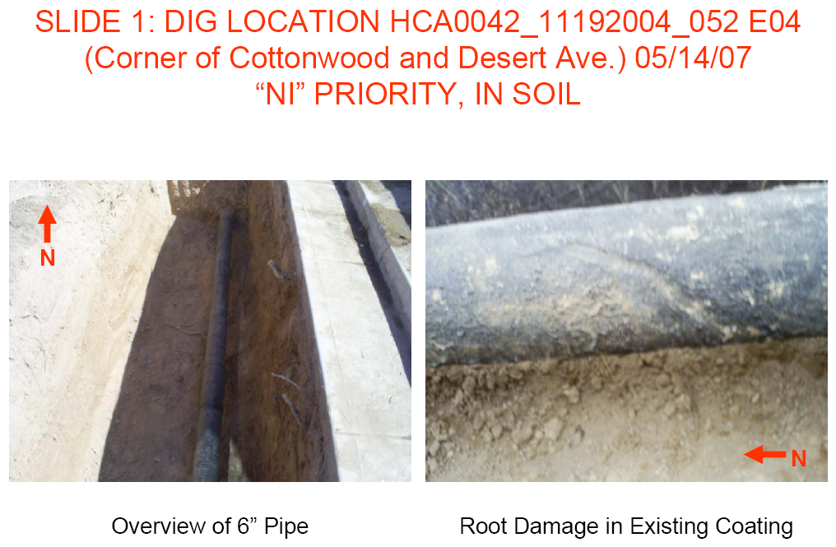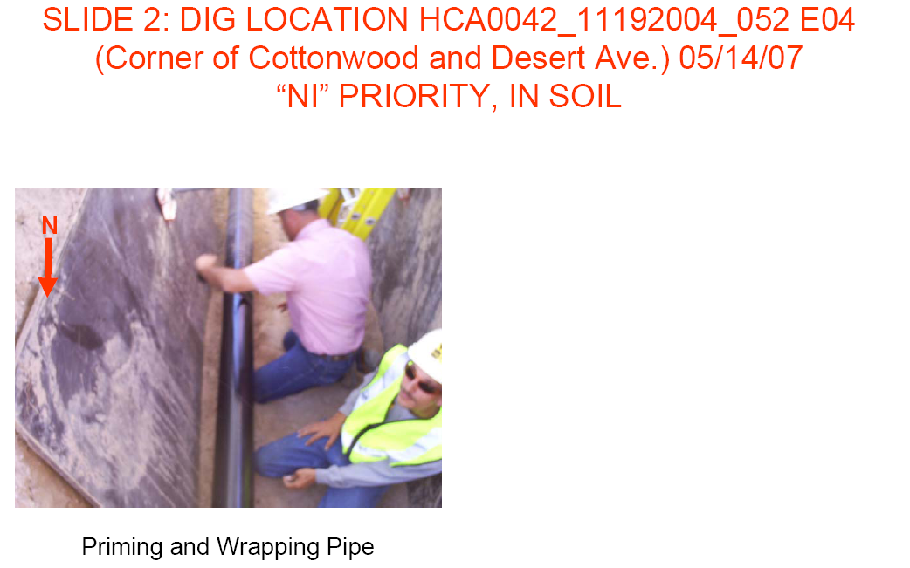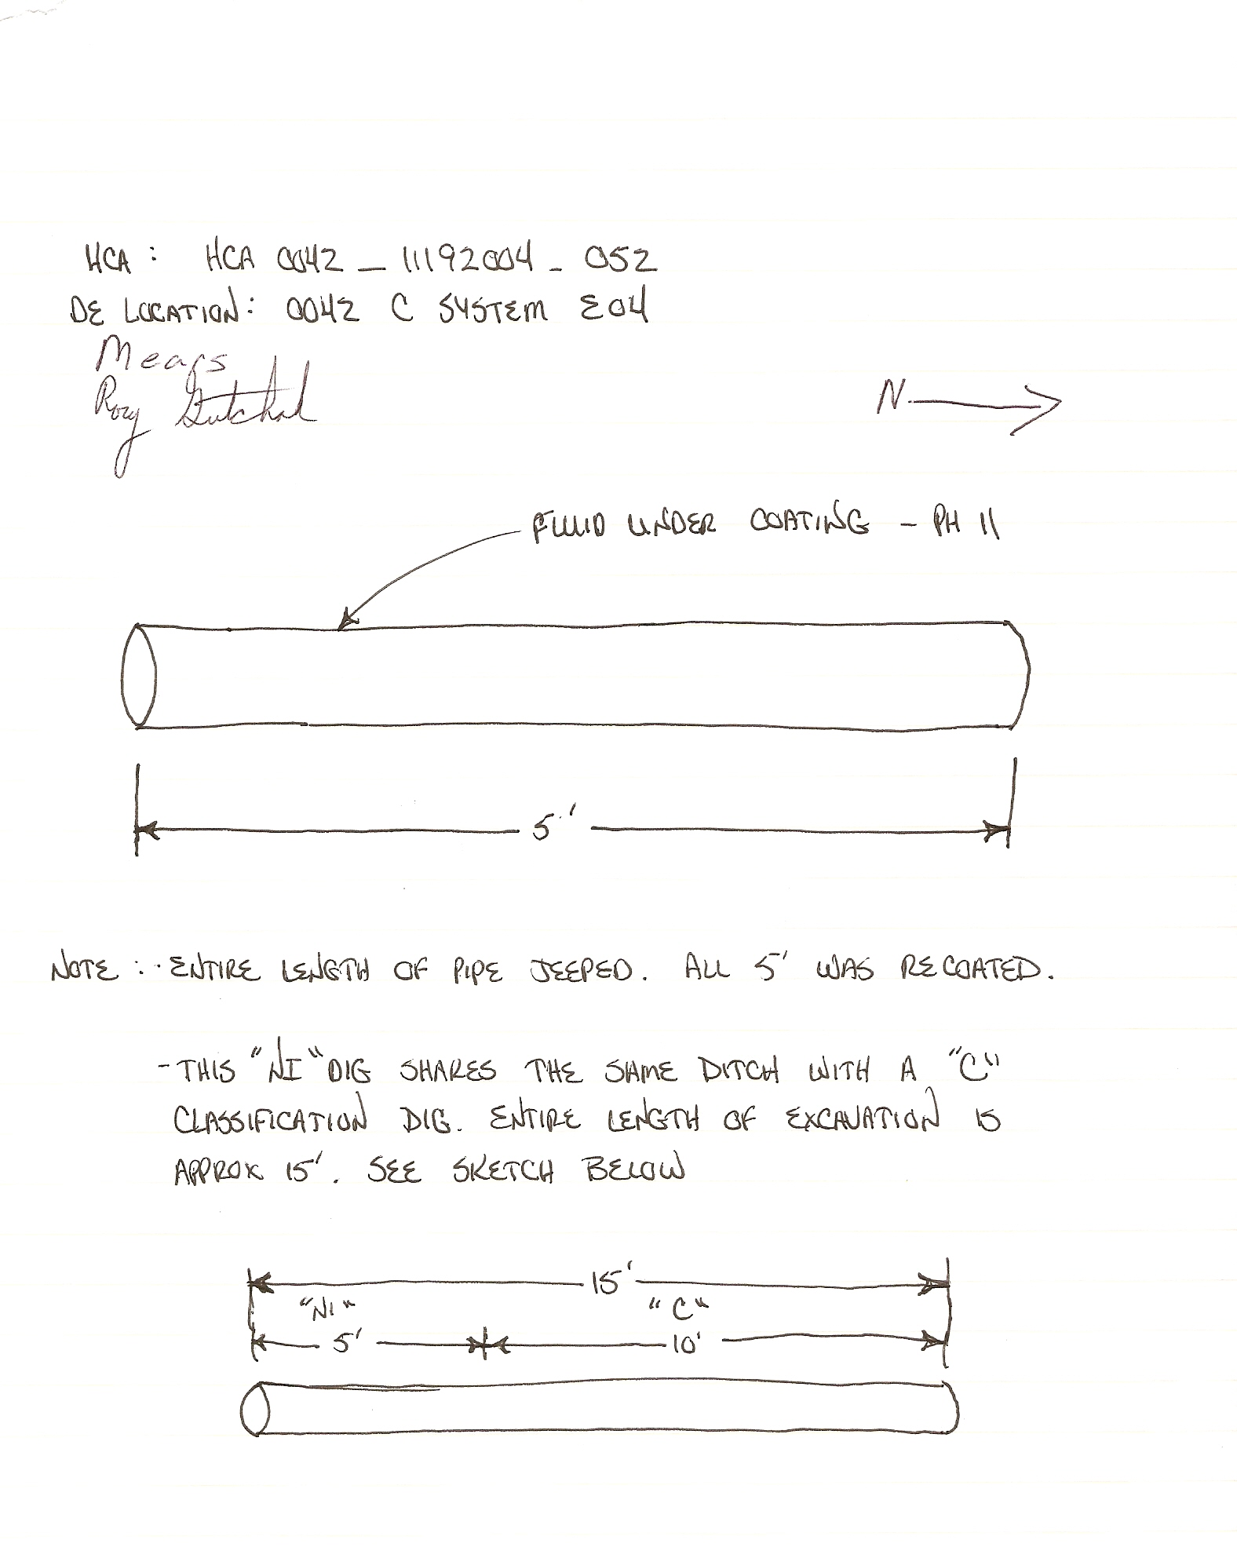

10